**1)Write a query to retrieve all orders placed by customers, including customer details (name, phone), order details (order ID, timestamp), and item details (product, amount).**

SELECT

c.name AS customer_name, c.phone AS customer_phone, o.order_id, o.order_timestamp, p.product_id, i.amount

FROM

"Local".customer c

JOIN

"Local".orders o ON c.customer = o.customer_id

JOIN

"Local".items i ON o.order_id = i.order_id

JOIN

"Local".products p ON i.product_id = p.product_id

ORDER BY

o.order_timestamp;

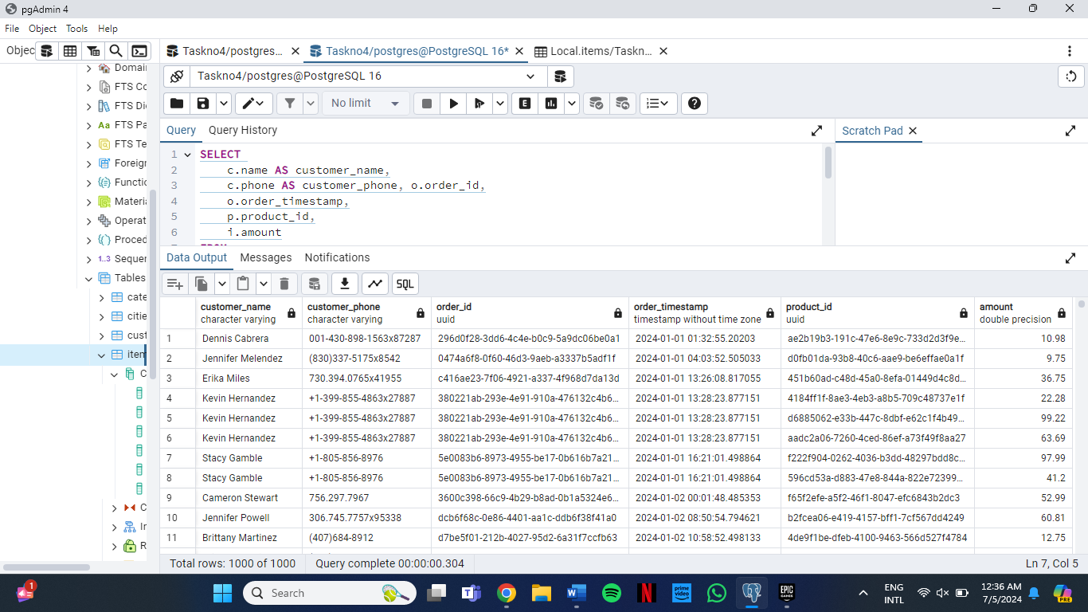

**2)** **Write a query to fetch all products along with their suppliers' details (name, phone) and the corresponding category name.**

SELECT

p.name AS product_name,

s.supplier_id,

s.phone AS supplier_phone,

c.name AS category_name

FROM

"Local".products p

LEFT JOIN

"Local".suppliers s ON p.supplier_id = s.supplier_id

LEFT JOIN

"Local".categories c ON p.category= c.category::text;

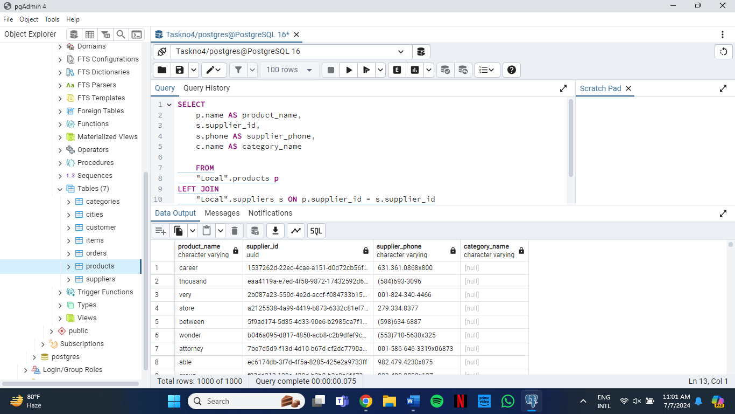

**3)Write a query to retrieve details of all orders including the product name and amount ordered for each item.**

SELECT

o.order_id,

p.name AS product_name,

i.amount

FROM

"Local".orders o

JOIN

"Local".items i ON o.order_id = i.order_id

JOIN

"Local".products p ON i.product_id = p.product_id

ORDER BY

o.order_id, i.amount;

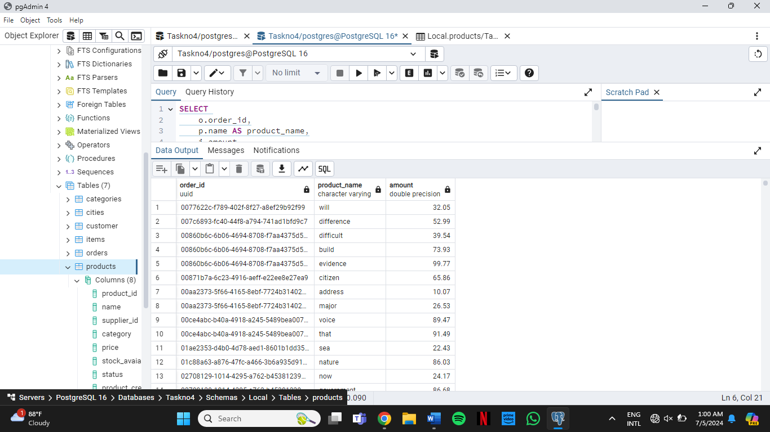

**4)** **Write a query to retrieve all suppliers along with the city and country where they are located, and the products they supply.**

SELECT

s.name AS supplier_name,

s.location AS supplier_location,

STRING_AGG(p.name, ', ') AS products_supplied

FROM

"Local".suppliers s

LEFT JOIN

"Local".products p ON s.supplier_id = p.supplier_id

GROUP BY

s.name, s.location

ORDER BY

s.name;

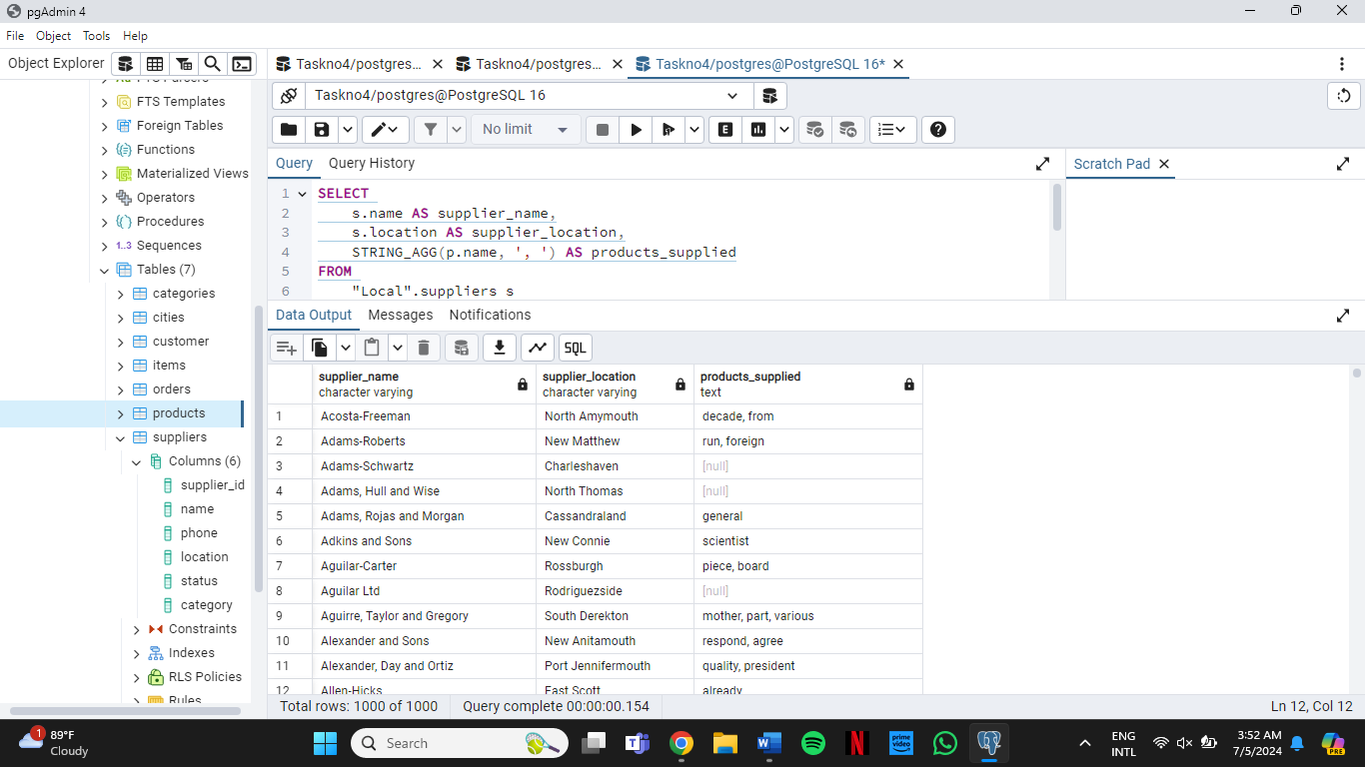

**5)Write a query to fetch details of the most recent order (by timestamp) placed by each customer, including the product details for each item in the order. [This question will use a Window Function alongside Joins]**

SELECT

c.customer,

c.name,

c.phone,

o.order_id,

o.order_timestamp,

p.product_id,

p.name

FROM

"Local".customer c

JOIN

"Local".orders o ON c.customer = o.customer_id

JOIN

"Local".items i ON o.order_id = i.order_id

JOIN

"Local".products p ON i.product_id = p.product_id

WHERE

(o.customer_id, o.order_timestamp) IN (

SELECT

o1.customer_id,

MAX(o1.order_timestamp) AS max_order_timestamp

FROM

"Local".orders o1

GROUP BY

o1.customer_id

)

ORDER BY

c.name, o.order_timestamp DESC;

